EX:NO:1 | Define the Problem Statement

6.01.2025

AIM
To design and develop a Software Requirements Specification (SRS) document for the Smart Energy Monitoring System that simulates electricity consumption, analyzes energy usage patterns, automatically calculates electricity bills, and provides optimization suggestions to help users reduce power consumption effectively.
1. INTRODUCTION
  - PURPOSE
The purpose of the Smart Energy Monitoring System is to provide a software-based platform that enables electricity consumers to monitor, analyze, and optimize their energy usage efficiently. The system simulates electricity meter readings, analyzes consumption patterns, calculates electricity bills automatically, and provides optimization suggestions to reduce overall power consumption.
  - SCOPE
IN-SCOPE
- Secure User authentication
- Rule-based energy consumption simulation
- Energy usage analytics
- Electricity bill calculation
- Budget tracking and alerts
- Administrator configuration and contro.
Out of Scope
- Smart meters and IoT devices
- Real-time Electricity Board (EB) server access
- AI/ML-based consumption prediction
- Mobile application development
  - Intended Users
- Domestic electricity consumers
- Commercial electricity consumers
- System Administrator

1.4 Software Development Model
The Incremental Model is adopted for developing this system. In this model, the system is developed in multiple phases. Each module is designed, implemented, tested, and integrated step by step. This approach improves reliability, flexibility, and easier error handling.
2. PROBLEM DEFINITION
2.1 Existing System
Traditional electricity meters display only cumulative readings. Consumers must manually calculate their energy consumption and electricity bills, which is often time-consuming and prone to errors.

2.2 Limitations of the Existing System
- No hourly or daily usage details
- Manual calculation of electricity bills
- No alerts for abnormal or excessive usage
- No optimization or energy-saving suggestions

2.3 Problem Statement
To design and develop a Smart Energy Monitoring System that simulates electricity usage, analyzes consumption patterns, automatically calculates electricity bills, and provides optimization suggestions — without the use of hardware components such as smart meters or IoT devices.
3. OBJECTIVES
3.1 Primary Objectives
- To simulate realistic electricity consumption
- To analyze energy usage patterns
- To automatically calculate electricity bills
- To detect abnormal consumption behavior
- To provide optimization suggestions for reducing power usage

3.2 Secondary Objectives
- To improve energy awareness among users
- To reduce electricity wastage
- 4. SYSTEM REQUIREMENTS

4.1 Functional Requirements
- FR1: The system shall provide secure user authentication.
- FR2: The system shall simulate energy consumption using predefined rules.
- FR3: The system shall process and store energy data securely.
- FR4: The system shall provide energy usage analytics.
- FR5: The system shall calculate electricity bills automatically.
- FR6: The system shall support budget management and tracking.
- FR7: The system shall generate alerts and optimization suggestions.
- FR8: The system shall allow admin configuration and control.

4.2 Non-Functional Requirements
- Security: The system shall ensure secure login and data protection.
- Performance: The system shall provide fast data processing and analytics.
- Usability: The system shall have a simple and user-friendly interface.
- Scalability: The system shall support future integration with IoT devices.

5. MODULES
- Authentication & Security
- Rule-Based Energy Simulation
- Energy Data Processing & Storage
- Energy Consumption Analytics
- Billing, Budget & Optimization
- Administration & System Configuration

RESULT
Thus, the documentation of the Software Requirements Specification (SRS) for the Smart Energy Monitoring System has been successfully completed.

EX:NO:2 | Identify use cases and develop business use case model  (System use case diagram)

6.01.2025

AIM
To identify the use cases of the Smart Energy Monitoring System and develop the Business Use Case Model (System Use Case Diagram) representing the functional interactions between users and the system.
ALGORITHM
- Study and analyze the system requirements.
- Identify the system boundary.
- Identify the primary and secondary actors (Users and Administrator).
- List all functional activities performed by each actor.
- Define the use cases based on functional requirements.
- Establish relationships between actors and use cases.
- Draw the System Use Case Diagram representing the interactions.
- Verify the diagram with the requirements specification.

USE CASE DIAGRAM
ACTORS AND THEIR USE CASES
1.CONSUMER (USER)
- Authenticate Consumer
- View Energy Usage & Analytics
- View Electricity Bill
- Calculate Electricity Bill (included in View Bill)
- Pay Bill
- Verify Payment (included in Pay Bill)
- Set Energy Budget
- Receive Alerts & Optimization Suggestions
- Generate Usage Report
- Update Profile
- Logout

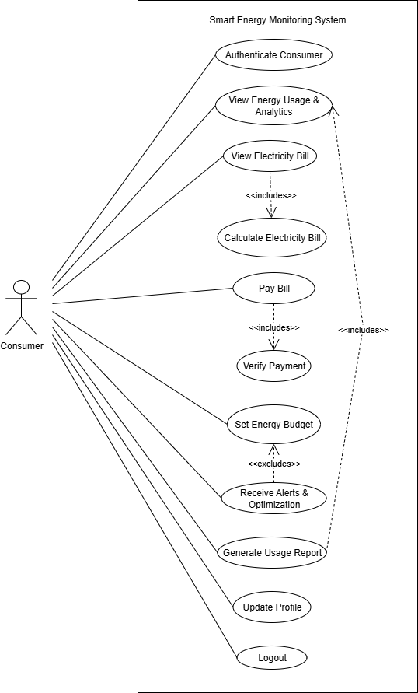

2.ADMINISTRATOR (ADMIN)
- Authenticate Admin
- Manage Users
- Configure Tariff Slabs
- Configure Simulation Rules
- Monitor Energy Statistics
- Generate System Report
- Manage Smart Meters (future scope / optional module)
- View System Logs
- Logout
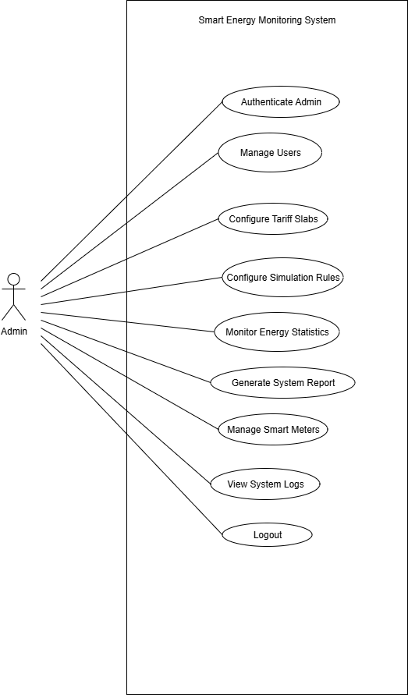

RESULT
Thus, the use cases of the Smart Energy Monitoring System were successfully identified, and the Business Use Case Model (System Use Case Diagram) was developed to represent the functional behavior and interactions of the system clearly.

AIM
To design and develop the Class Diagram for the Smart Energy Monitoring System representing the system’s static structure, including classes, attributes, methods, and relationships.

ALGORITHM
- Study the system requirements and functional specifications.
- Identify the major entities involved in the system.
- Define classes based on system entities.
- Assign appropriate attributes to each class.
- Define methods (operations) for each class.
- Establish relationships between classes (association, inheritance, aggregation).
- Specify multiplicity wherever required.
- Draw the Class Diagram and verify it with the system requirements.

CLASSES
- User
- Consumer
- Admin
- Authentication
- Bill
- Payment
- Tariff
- SmartMeter
- EnergyReading
- Analytics
- Report
- Budget
- Alert
- SystemLog
EX:NO: 3 | Identify the conceptual classes (boundary, controller, and entity classes) and develop a domain model with UML Class diagram.

6.01.2025

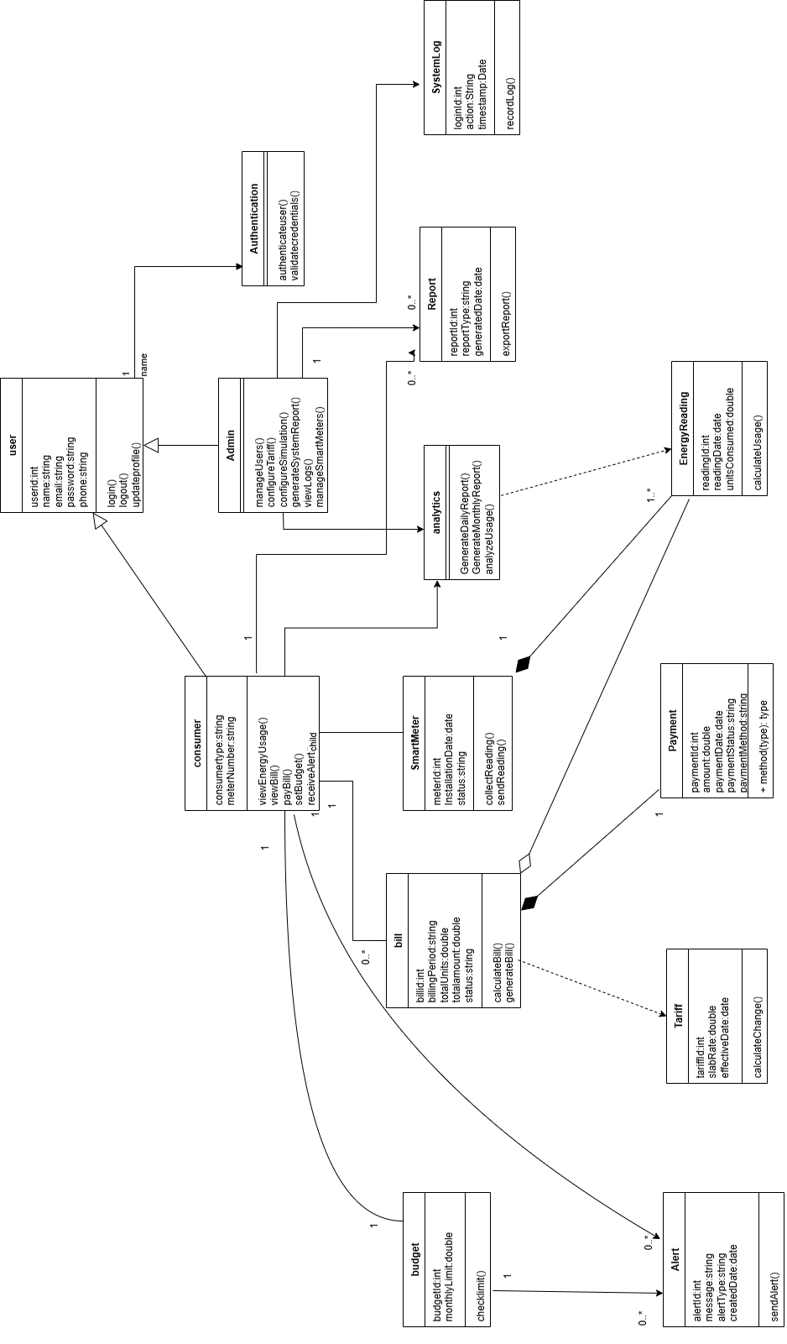

RESULT
Thus, the Class Diagram for the Smart Energy Monitoring System was successfully designed. The diagram clearly represents the system structure, classes, attributes, methods, inheritance relationships, and associations, providing a clear understanding of the system’s static architecture.
EX:NO: 4 | Using the identified scenarios find the interaction between objects and represent them using UML Interaction diagram

6.01.2025

AIM

To identify the interactions between objects in the given scenarios and represent them using a UML Interaction Diagram (Sequence Diagram or Communication Diagram).

ALGORITHM
- Study the system requirements and functional specifications carefully.
- Identify the scenarios (use cases) that describe the dynamic behavior of the system.
- Identify the major objects (actors, boundary, control, and entity objects) involved in each scenario.
- Determine the responsibilities of each identified object in the scenario.
- Identify the messages exchanged between objects to accomplish the required functionality.
- Arrange the messages in chronological order according to the flow of execution.
- Select the appropriate UML Interaction Diagram type (Sequence Diagram or Communication Diagram).
- Draw lifelines for each object (in case of Sequence Diagram) or object nodes (in case of Communication Diagram).
- Represent message passing using arrows and label them with method names.
- Indicate activation bars (if required) and return messages.
- Number the messages properly (mandatory in Communication Diagram).
- Verify the diagram with the given scenario to ensure all interactions are correctly represented.
Sequence Diagram – User Login
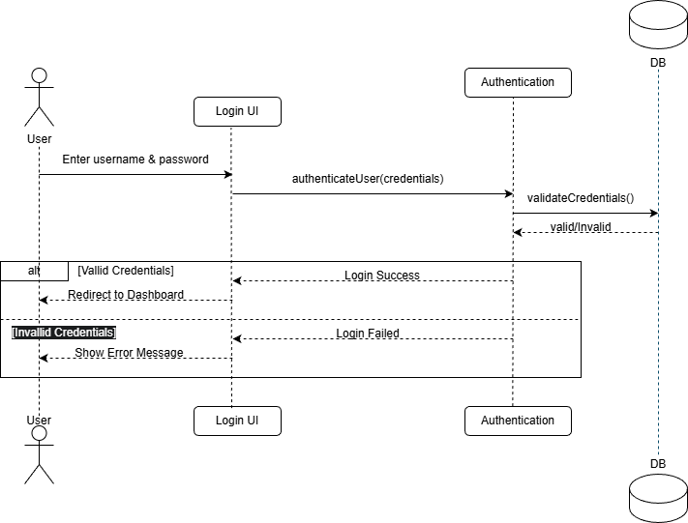

Sequence Diagram – View Energy Usage & Analytics
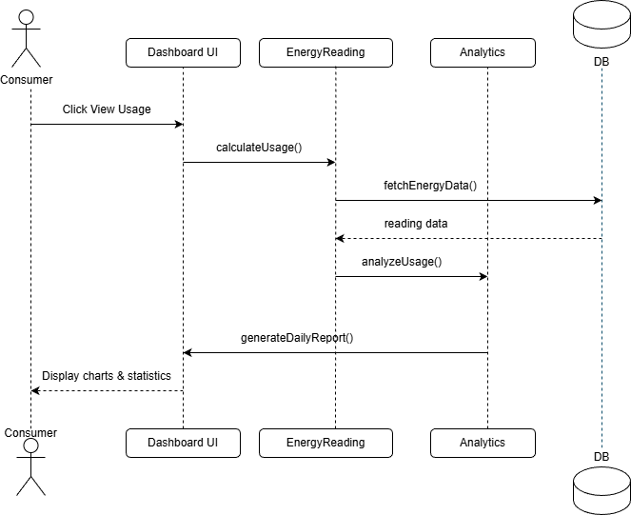
Sequence Diagram - Pay Bill
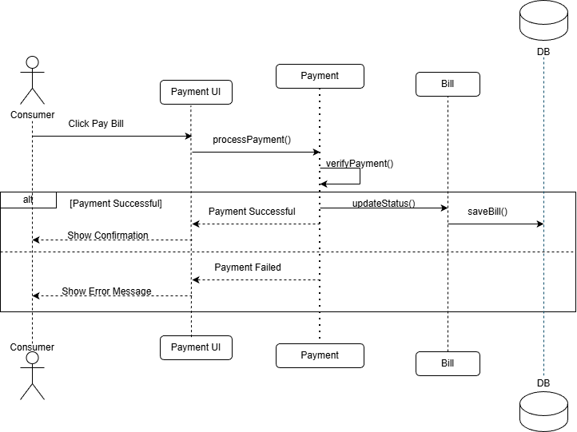
Sequence Diagram - Set Budget & Receive Alert
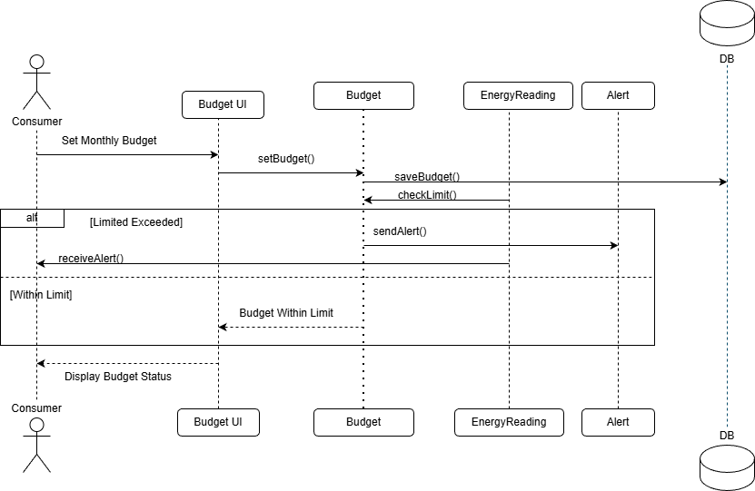
Sequence Diagram - Admin Configure Tariff
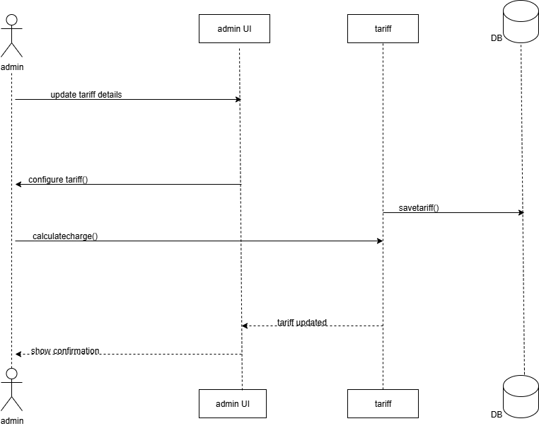

Sequence Diagram - Generate System Report
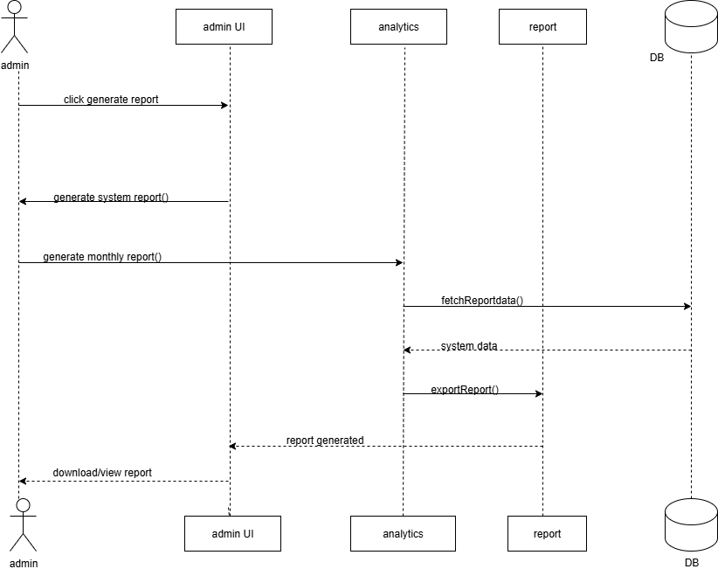
Sequence Diagram - Generate Electricity Bill
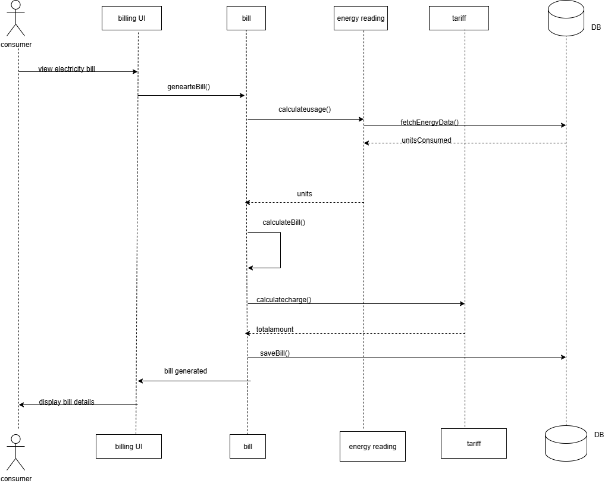

RESULT
The interaction between identified objects has been successfully analyzed and represented using a UML Interaction Diagram, showing the sequence of message exchanges and dynamic behavior of the system according to the given scenario.
EX:NO: 5 | Draw the State Chart diagram and UML Activity diagram

6.01.2025

AIM

To model the dynamic behavior of a system by representing different states of an object and the transitions between those states using a UML State Chart Diagram.

ALGORITHM
- Study the system requirements and identify the object whose behavior changes over time.
- Identify all possible states of the selected object during its lifecycle.
- Determine the initial state and final state of the object.
- Identify events that cause transitions from one state to another.
- Define actions/activities that occur during state transitions (if any).
- Identify conditional transitions (guards) wherever required.
- Represent the initial state using a filled circle.
- Draw rounded rectangles to represent different states.
- Connect states using directed arrows to show transitions.
- Label each transition with event names and conditions (if applicable).
- Represent the final state using a circle with a dot inside.
- Verify the State Chart Diagram with system requirements to ensure all states and transitions are covered correctly.
State Diagram - User Authentication
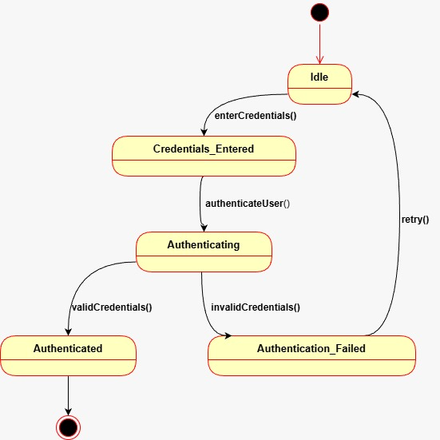
State Diagram - View Energy Usage
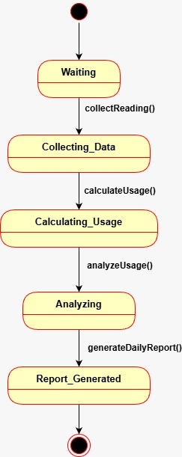
State Diagram - Generate Electricity Bill
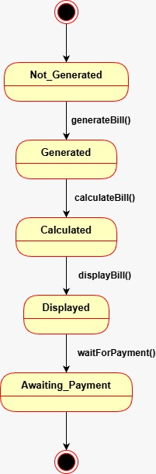
State Diagram - Pay Bill
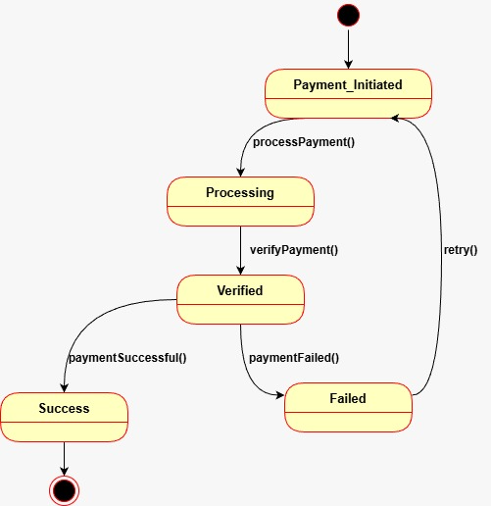
State Diagram - Budget & Alert
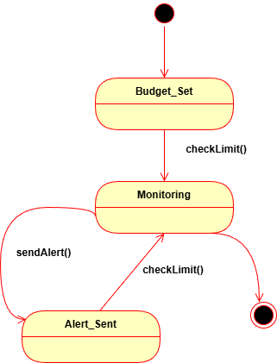
State Diagram - Energy Usage
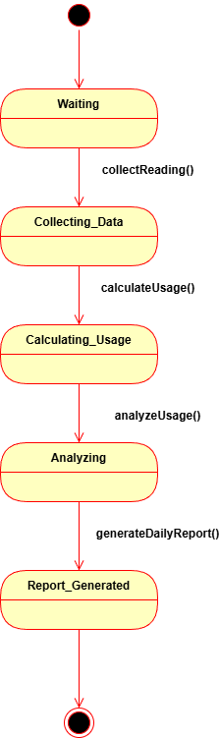
State Diagram - Tariff Configuration
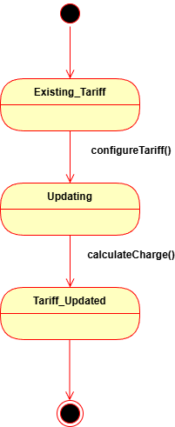
State Diagram - Report Generation

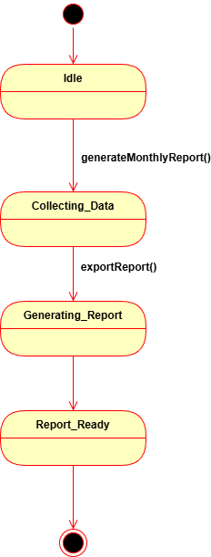

Result
The State Chart Diagram was successfully drawn, representing the various states of the object and the transitions between them based on events and conditions. The diagram clearly models the dynamic behavior of the system.

